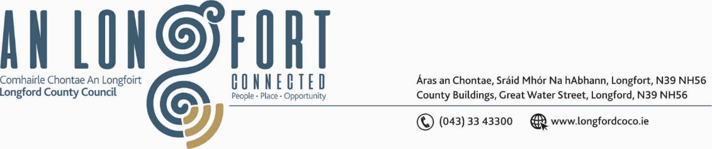

***BALLYMAHON MUNICIPAL DISTRICT***

***Please note meeting will be held in Ballymahon Library.***

**16 March 2023.**

**To: Each Member of Ballymahon Municipal District.**

**Dear Member,**

You are requested to attend a Meeting of Ballymahon Municipal District to be held

**in Ballymahon Library** on **Tuesday 23 March 2023 at 4pm** to transact business, as set out on the agenda hereunder.

**Yours sincerely**,

Claire McNabola

_______________

**Claire McNabola,**

**Meetings Administrator.**

**AGENDA**

Prayer before meeting.

Presentation from Healthy Age Friendly Homes Local Coordinator.

**1.** Confirmation of Minutes of Ballymahon Municipal District Meeting held on the 26 January 2022 – enclosed.

**2.** Matters arising from Minutes.

**3.** Declaration of Interest by Members.

**4.** Management Report - enclosed.

**5.** Nominations of Elected members for the Creative Ireland Culture Team 2023-2027

**6.** Consideration of Schedule of Ballymahon Municipal District Works – enclosed

**7. Notices of Motions, submitted by Councillors, as listed hereunder –**

**Councillor Paul Ross**

1. That Longford install crash barriers on the stretch of road on the Lissard House entrance, Cartron Reagh, Edgeworthstown on the L-1089 and also include this route on the winter gritted roads list.

1. That Longford County Council seek funding to install a safe cycleway/walkway up Ardagh Mountain from the moor to connect the mountain walk back to the village.
2. That Longford Co Council seek funding to install a dedicated off-road mountain bike trail in Newcastle forest to cater for this fast growing sport.

**Councillor Pat O’Toole**

I call on Longford County Council in conjunction with Bus Éireann to assess the feasibility of providing two bus shelters at the bus stops at upper Main Street Ballymahon.

**Councillor Colm Murray**

1. I call on Longford County Council to carry out improvement works at the crossroads known locally as The Plantation Cross, Abbeyderg, Kenagh, on the L1126 in order to better display the right of way and road markings.
2. I call on Longford County Council to carry out works at the Bridge at Corlea, Kenagh along the R392 as the road is subsiding on either side of the bridge, thus making it hazardous to motorists.